AI Internship Assignment – Task 7
Submitted By: Eman Ansar
Repository Name: ai-internship-emanansar
Domain: AI & Software Development
Date: 10-7-2026

Task 07 — Machine Learning Foundations: Train/Test Split, Model Fit, and Linear Regression
1. Screenshot showing the Python environment with scikit-learn, pandas, numpy, and matplotlib installed
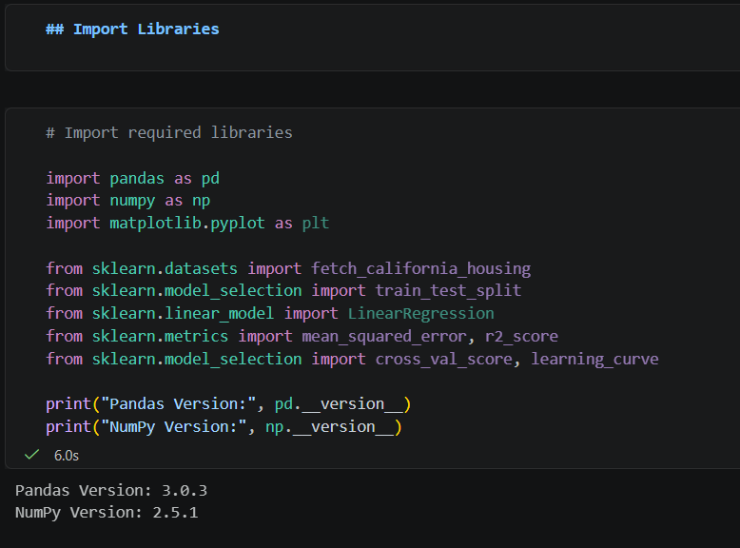

Part A — ML Theory: Train/Test Split (20 Marks)
1. Explain why a dataset is split into training and testing sets, and what problem this solves.
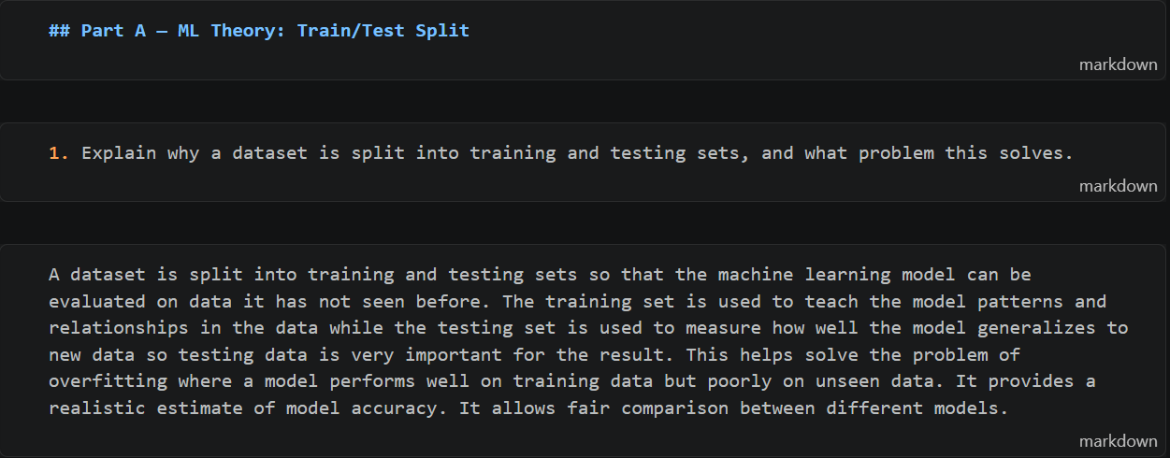
2. Describe the typical split ratios used in practice (e.g., 80/20, 70/30) and when each is appropriate.
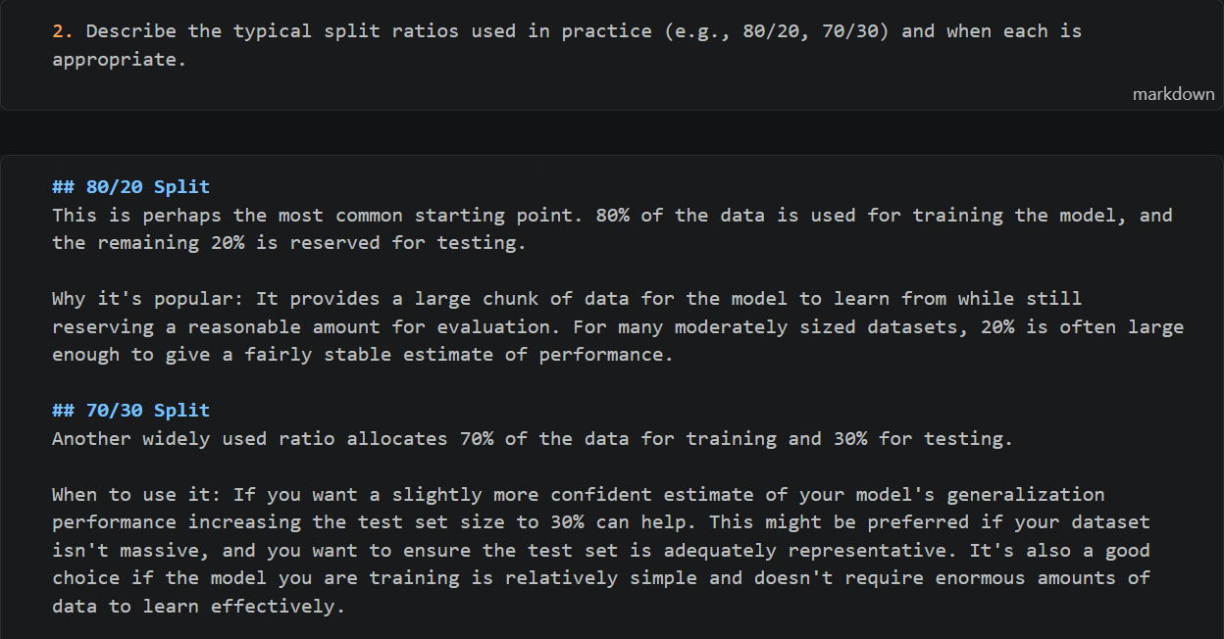

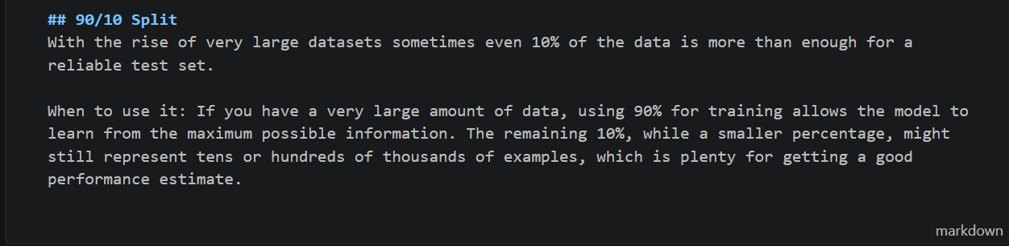
3. Implement a train/test split on a sample dataset using scikit-learn's train_test_split.
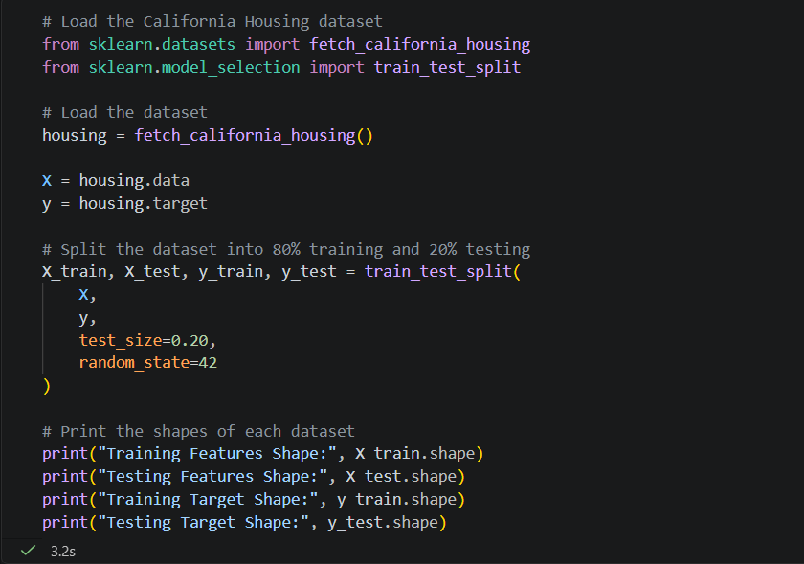

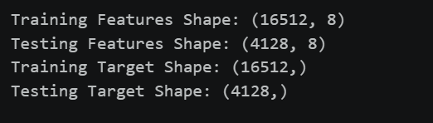
OUTPUT:

4. Explain the role of the random_state parameter and why it matters for reproducibility.
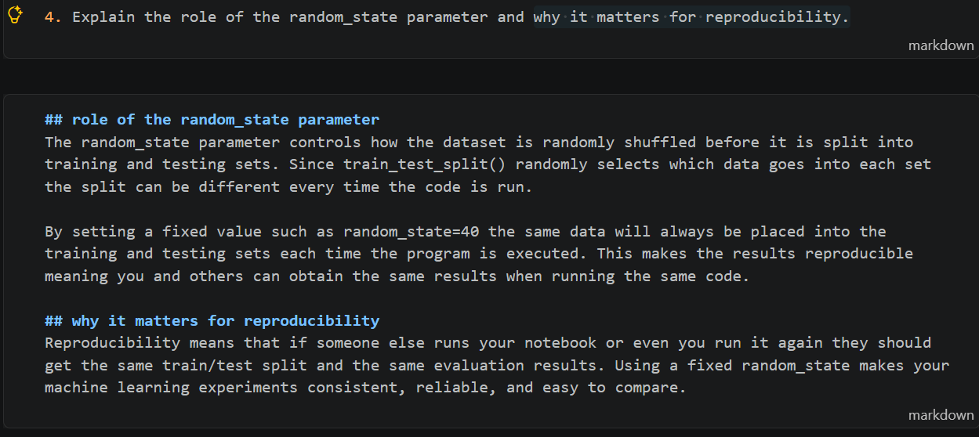

5. Discuss what a validation set is and how it differs from a test set.
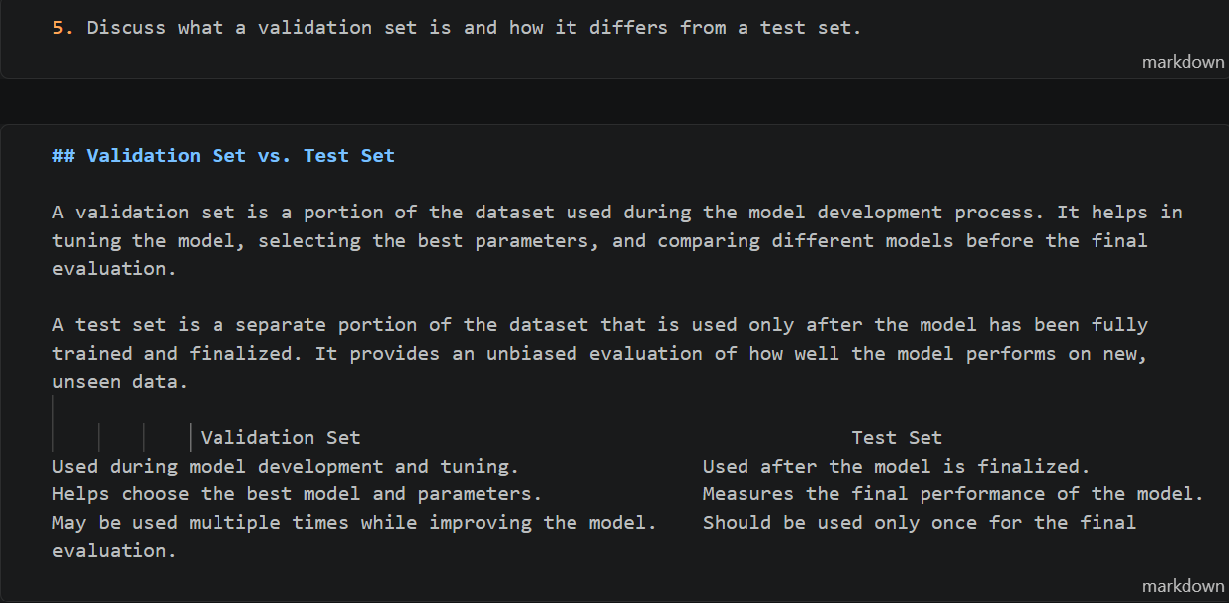
Part B — ML Theory: Overfitting, Underfitting & Bias-Variance Tradeoff (20 Marks)
1. Define overfitting and underfitting, with a real or constructed example of each.
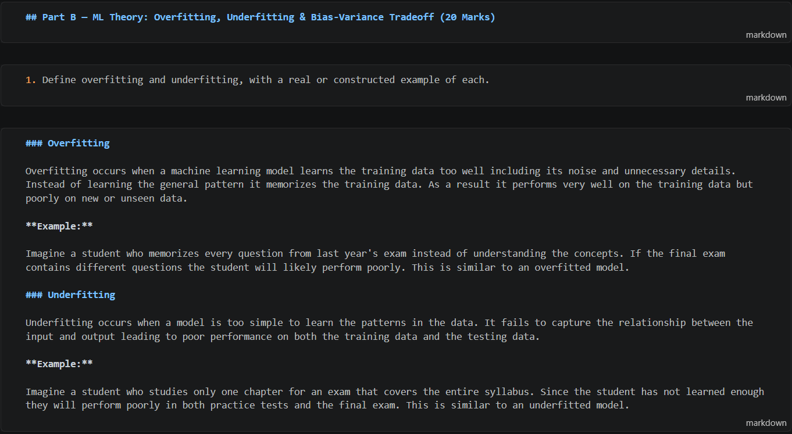

2. Explain the bias-variance tradeoff and how it relates to model complexity.
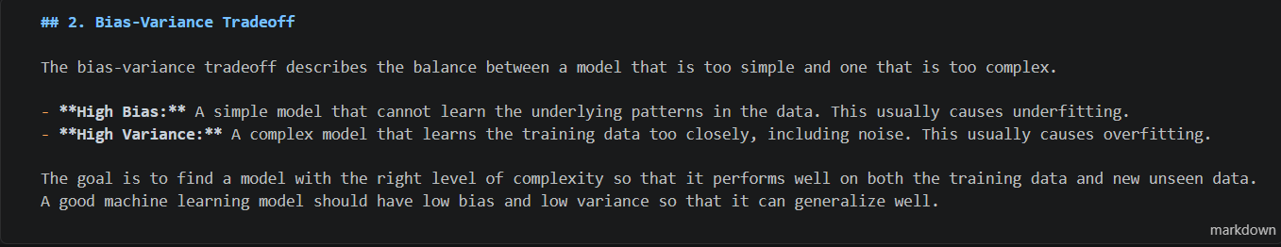

3. Describe at least three practical techniques to reduce overfitting (e.g., regularization, cross-validation, more data, simpler models, early stopping).
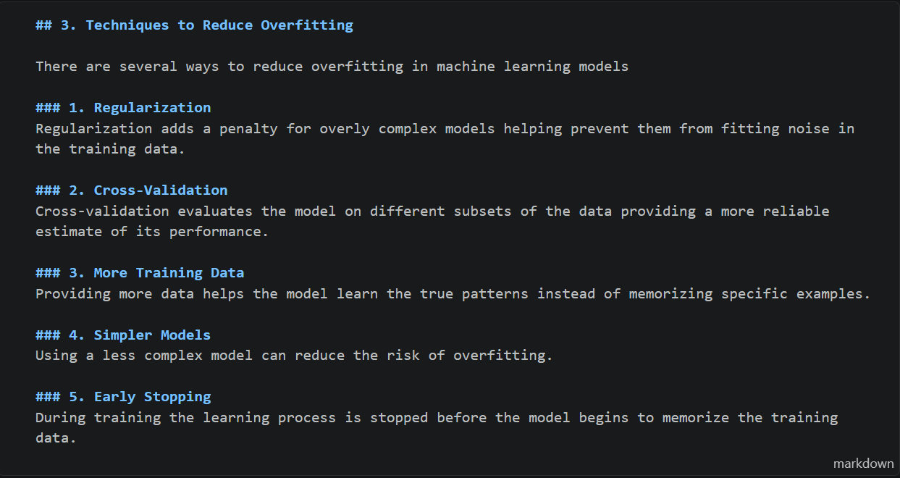

4. Plot training error vs. test error for models of increasing complexity (e.g., polynomial regression of increasing degree) to visually demonstrate the tradeoff.
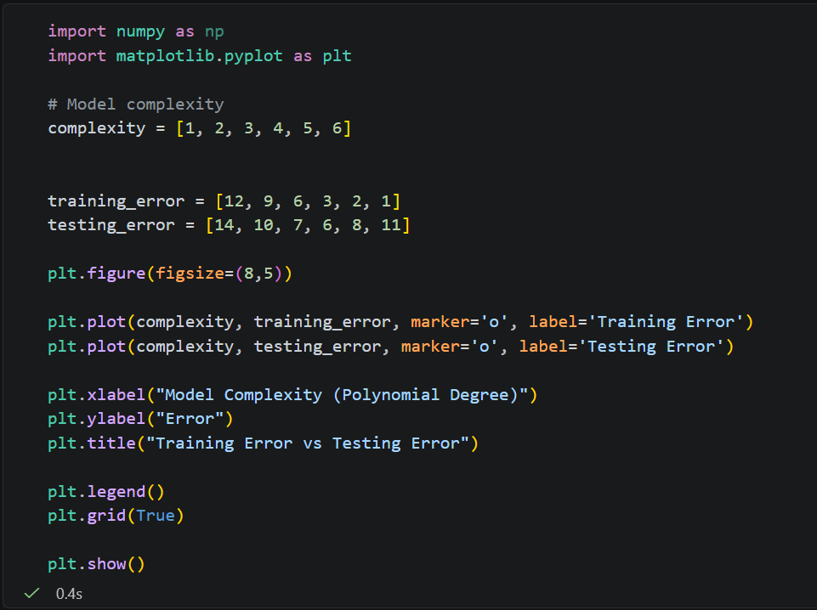
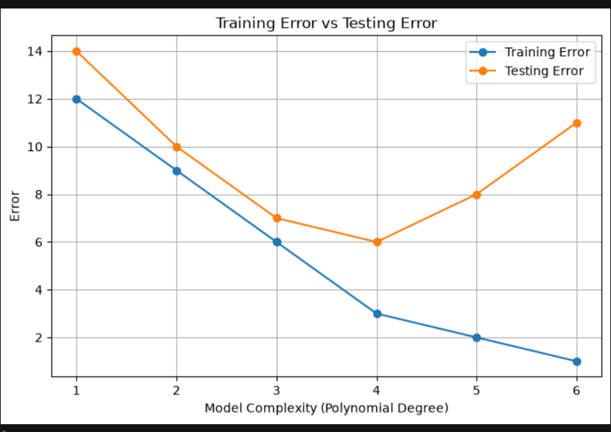

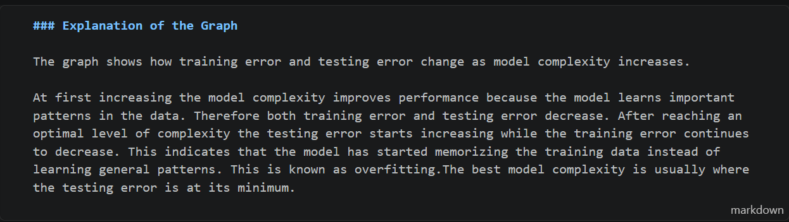
5. Summarize, in your own words, how you would diagnose whether a model is overfitting or underfitting from its training/test performance.
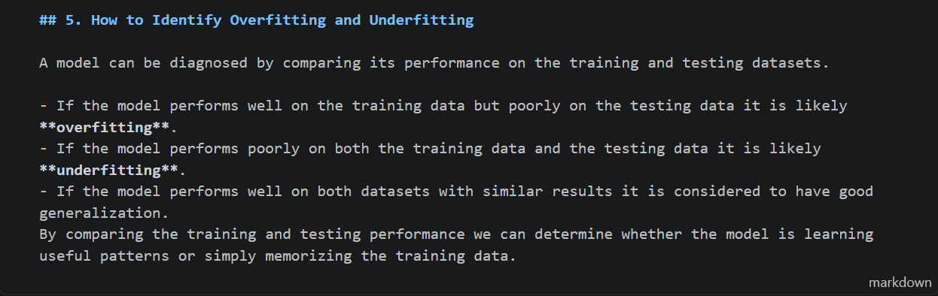
Part C — Linear Regression: Theory & Implementation (30 Marks)
1. Explain the mathematical form of simple linear regression (y = mx + b) and multiple linear regression.
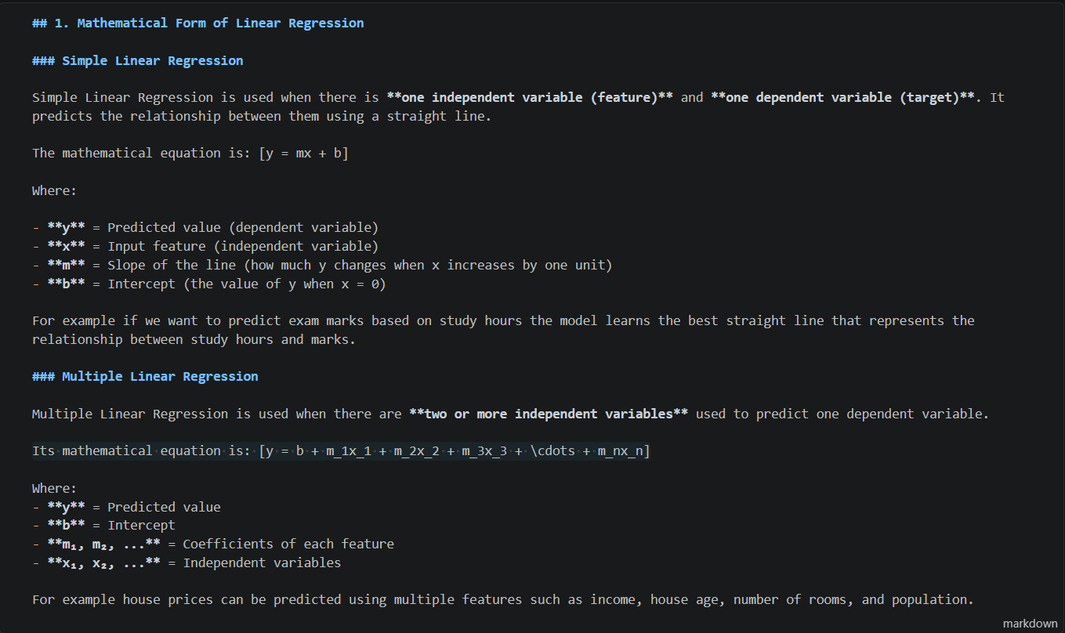

2. Explain how the model's coefficients are learned (cost function and gradient descent, or the normal equation).
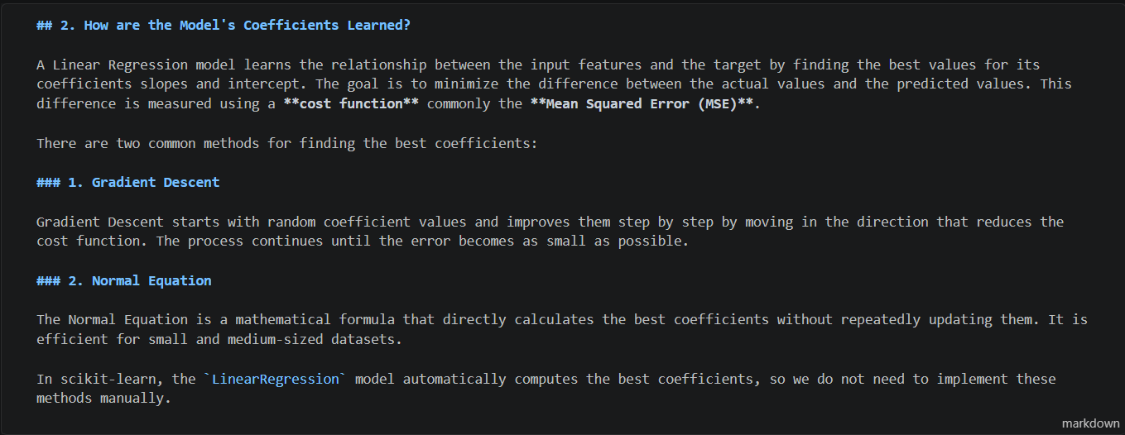

3. Load a dataset (e.g., a small CSV of your choice or a scikit-learn built-in dataset) and prepare it for modeling.
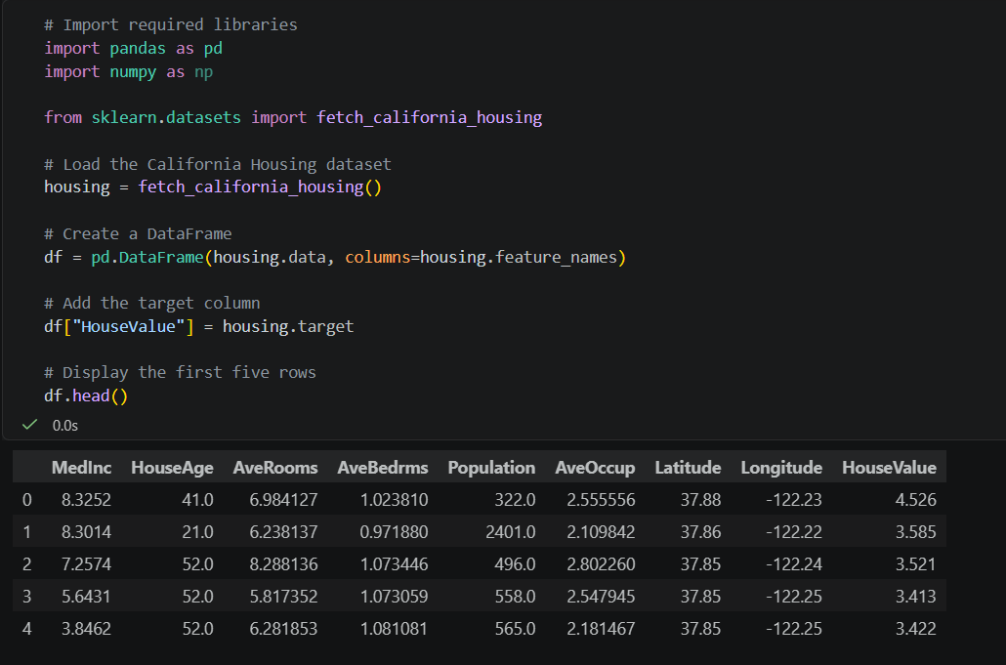

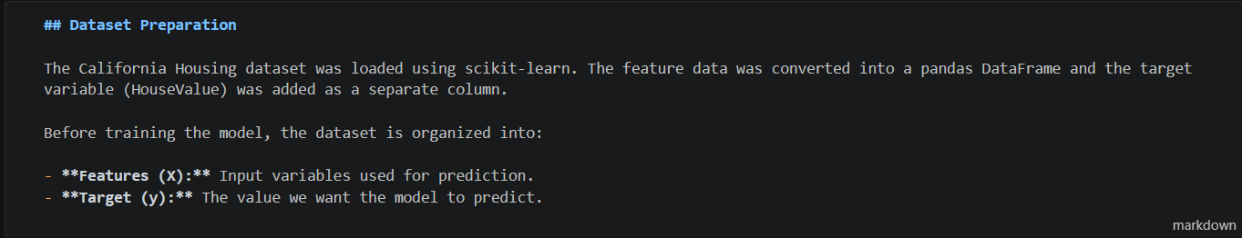
4. Split the data into training and test sets, then train a LinearRegression model from scikit-learn.
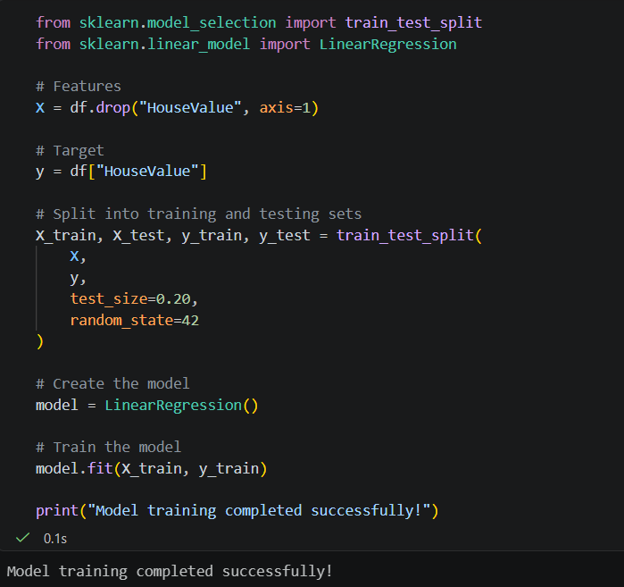
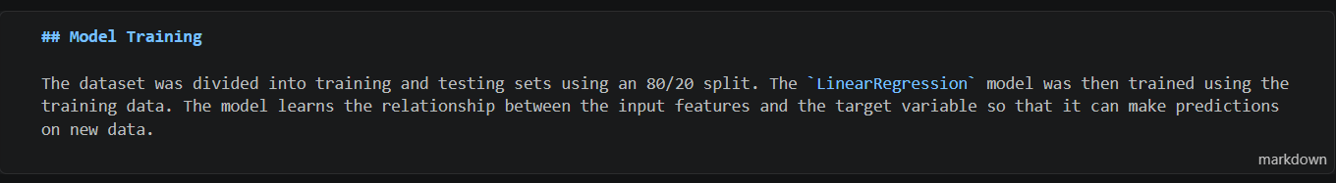

5. Evaluate the model using appropriate metrics (e.g., Mean Squared Error, R² score) and interpret the results.
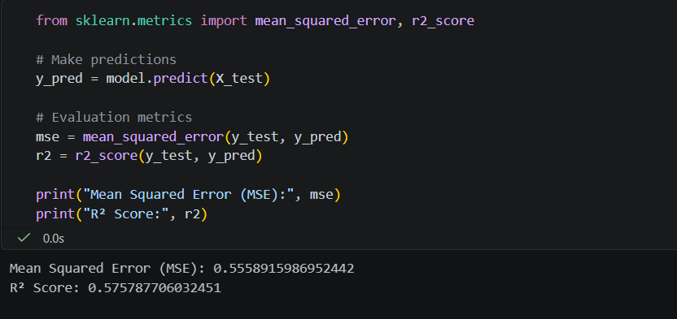
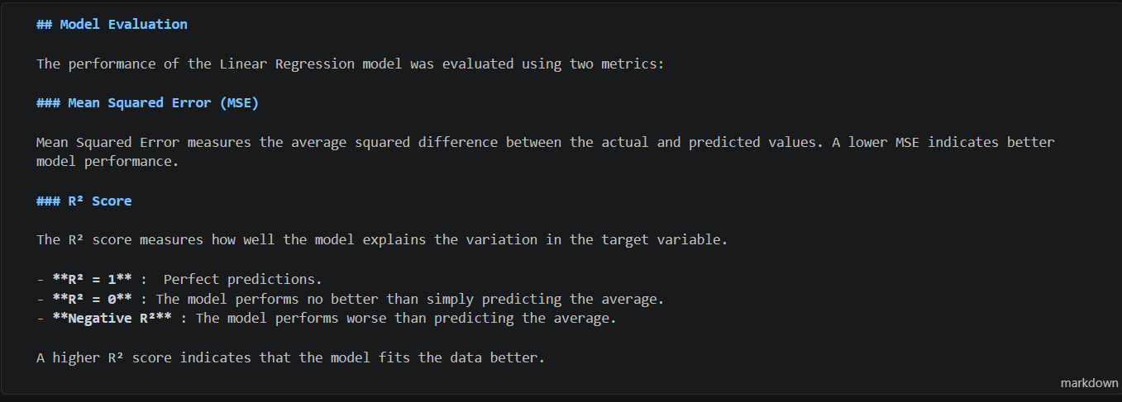

6. Plot the regression line (or predicted vs. actual values) against the data.
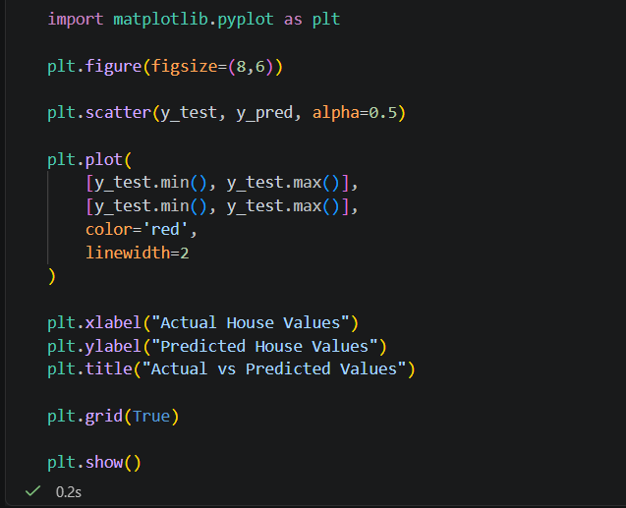

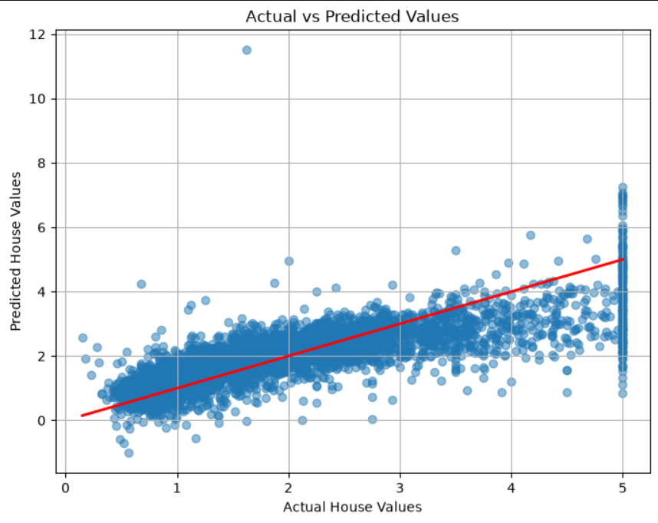

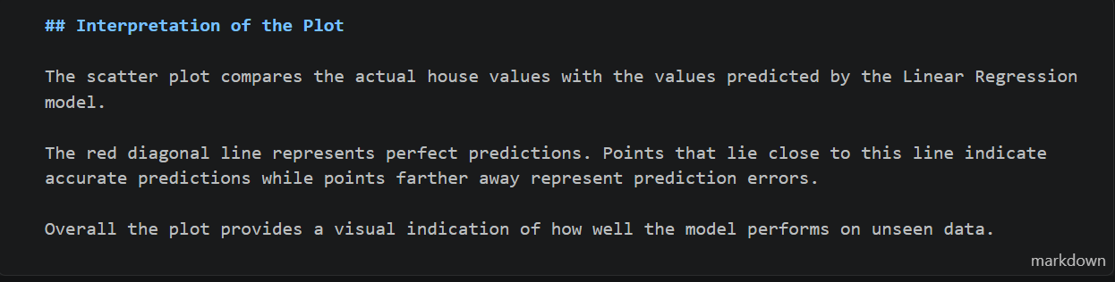

Part D — Practical Coding Session (30 Marks)
1. Load a raw CSV dataset, handle missing values, and encode any categorical columns before modeling.
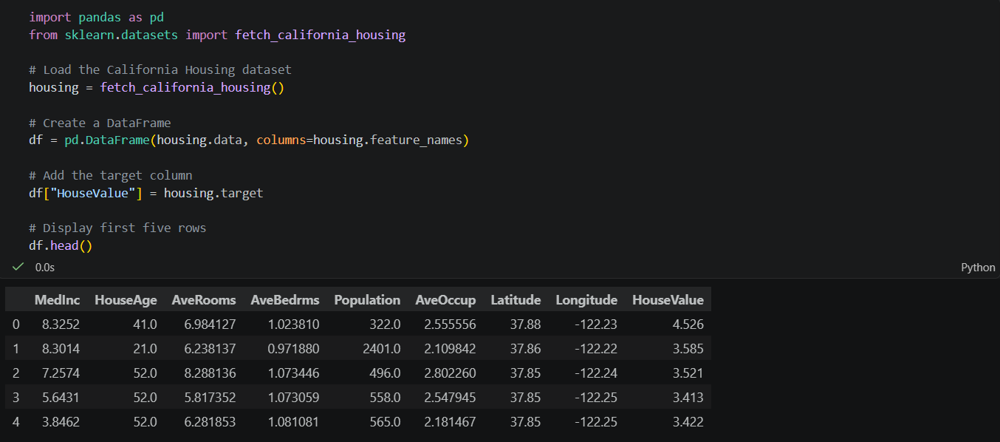
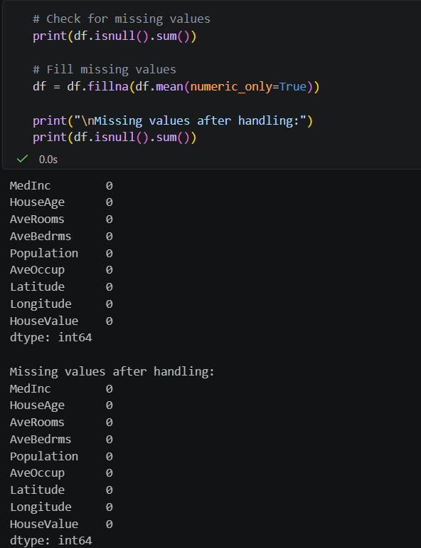

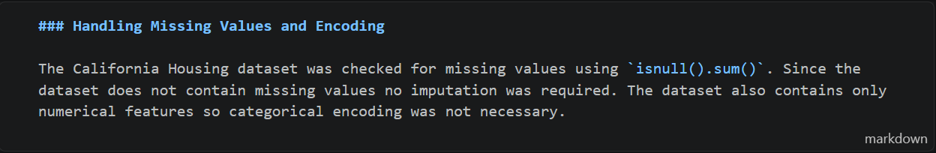
2. Write a function that takes a dataset and a split ratio, returns train/test sets, and prints the resulting shapes.
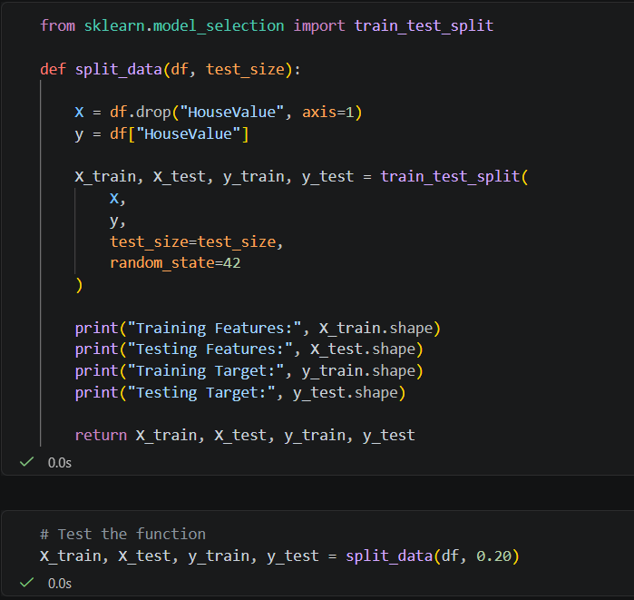
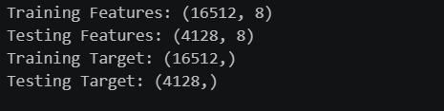

3. Train the same Linear Regression model on three different train/test split ratios (e.g., 60/40, 80/20, 90/10) and compare the evaluation metrics in a small table.
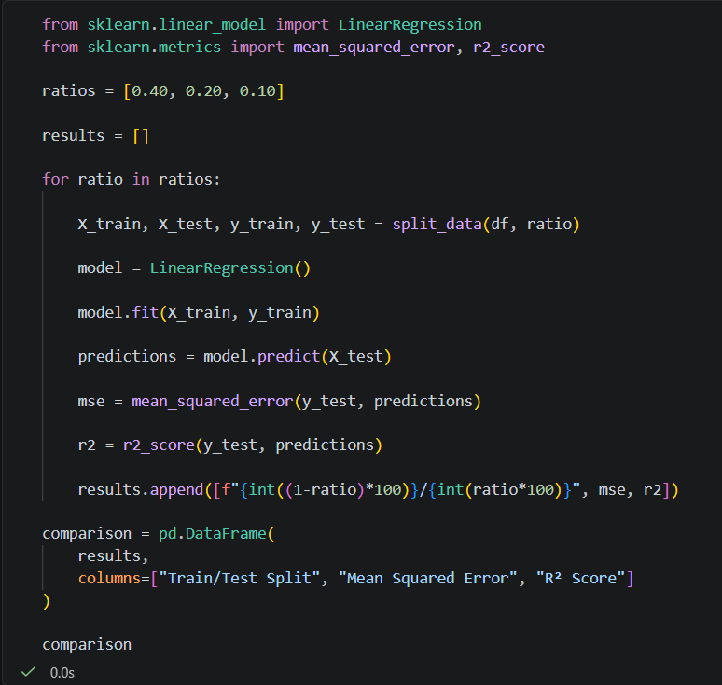

Compare the evaluation metrics in a small table.
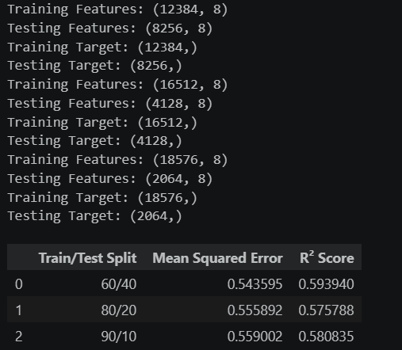

4. Use scikit-learn's cross_val_score to perform k-fold cross-validation on your model and report the average score.
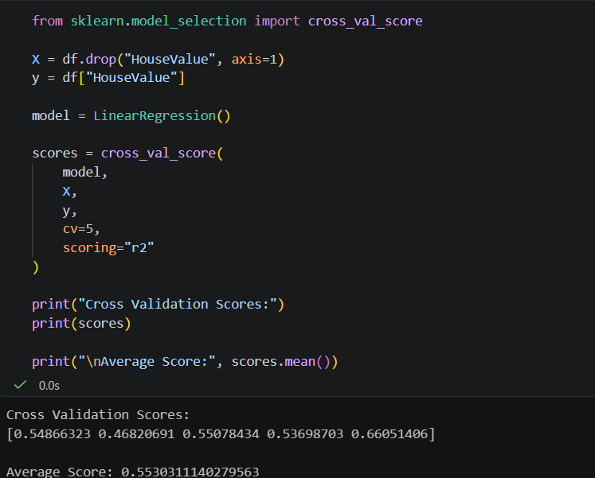

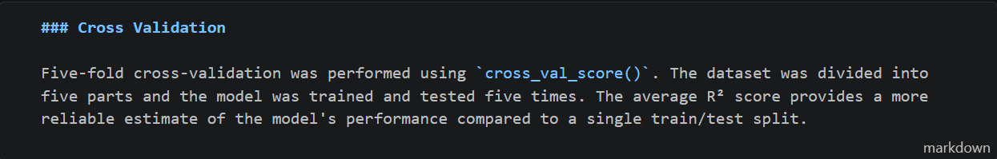

5. Plot a learning curve (training score vs. test score as training set size increases) and explain what it shows about overfitting or underfitting.
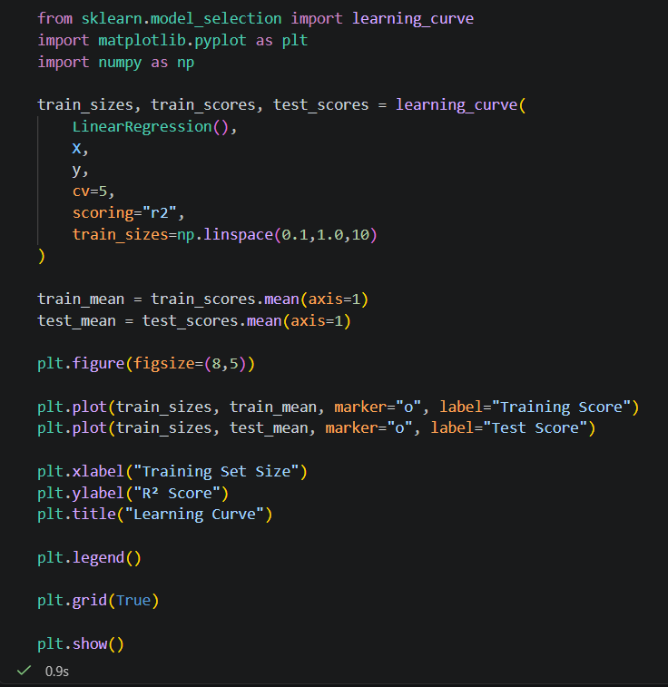

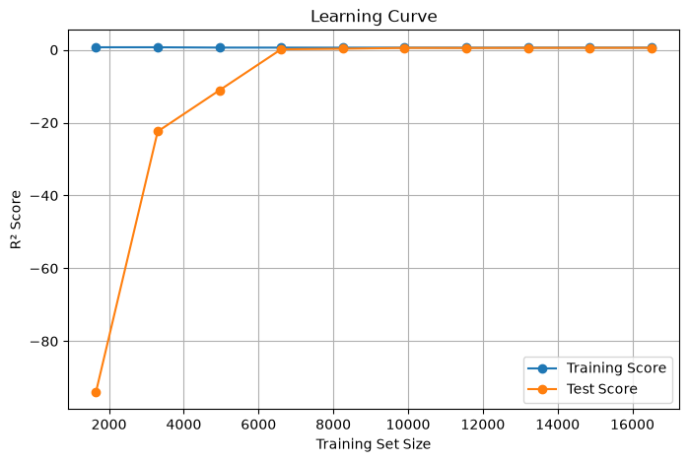

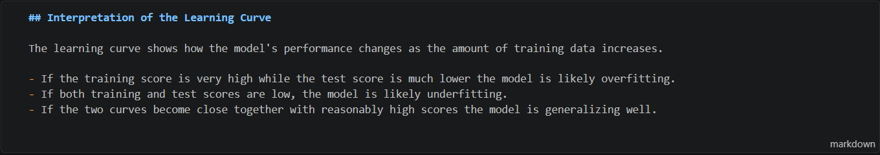

6. Refactor your notebook code into reusable functions (e.g., load_data(), split_data(), train_model(), evaluate_model()).
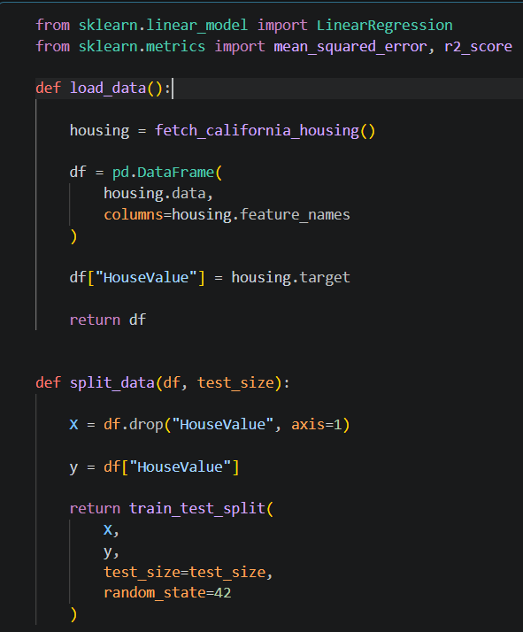

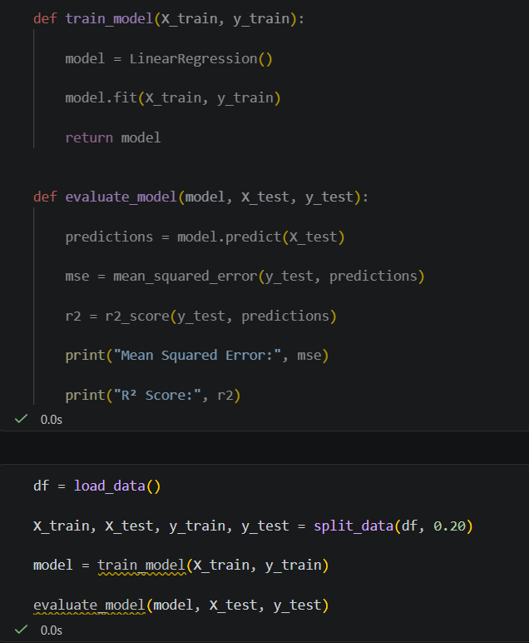

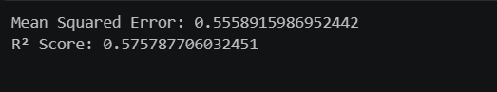

Bonus Task (+10 Marks)
Extend your Linear Regression model with polynomial features (degree 2 or 3) and compare its performance against the plain linear model. Explain, using your results, whether the polynomial version overfits, underfits, or generalizes better.
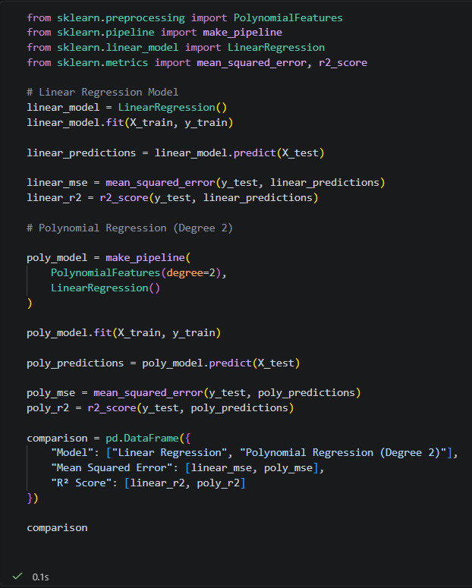

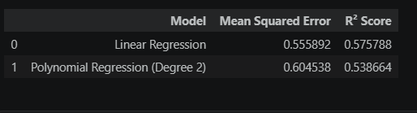

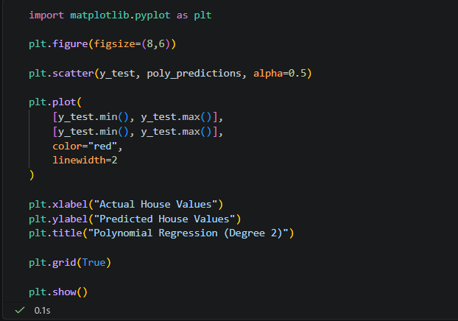

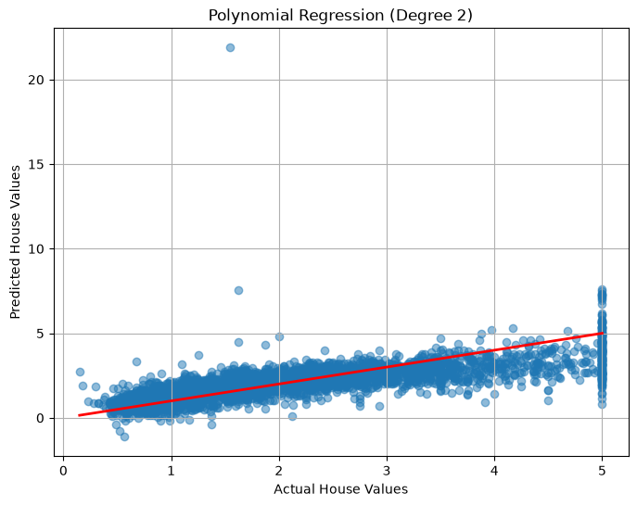

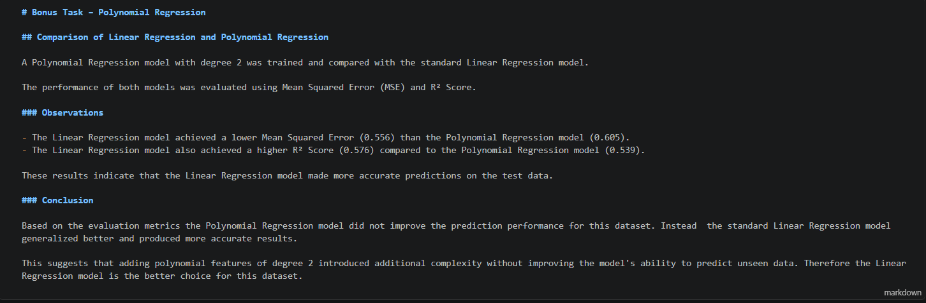

Github Ripository Link:
https://github.com/63852-EmanAnsar/ai-internship-emanansar

